Atitit 词云 字符云 的艺术

<http://echarts.baidu.com/echarts2/doc/example/wordCloud.html>

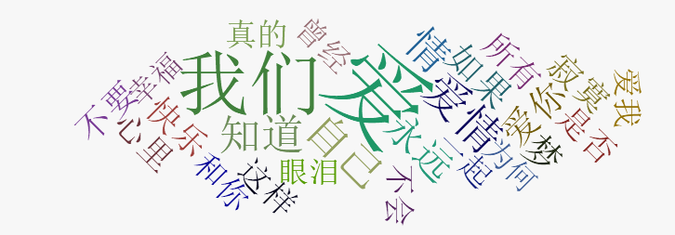

{

name: "爱",

value: 1155.0,

itemStyle: createRandomItemStyle()

} , {

name: "我们",

value: 967.0,

itemStyle: createRandomItemStyle()

} , {

name: "爱情",

value: 417.0,

itemStyle: createRandomItemStyle()

} , {

name: "自己",

value: 337.0,

itemStyle: createRandomItemStyle()

} , {

name: "知道",

value: 332.0,

itemStyle: createRandomItemStyle()

} , {

name: "永远",

value: 297.0,

itemStyle: createRandomItemStyle()

} , {

name: "如果",

value: 288.0,

itemStyle: createRandomItemStyle()

} , {

name: "爱你",

value: 287.0,

itemStyle: createRandomItemStyle()

} , {

name: "快乐",

value: 245.0,

itemStyle: createRandomItemStyle()

} , {

name: "情",

value: 244.0,

itemStyle: createRandomItemStyle()

} , {

name: "所有",

value: 223.0,

itemStyle: createRandomItemStyle()

} , {

name: "曾经",

value: 222.0,

itemStyle: createRandomItemStyle()

} , {

name: "一起",

value: 215.0,

itemStyle: createRandomItemStyle()

} , {

name: "眼泪",

value: 213.0,

itemStyle: createRandomItemStyle()

} , {

name: "幸福",

value: 212.0,

itemStyle: createRandomItemStyle()

} , {

name: "梦",

value: 210.0,

itemStyle: createRandomItemStyle()

} , {

name: "寂寞",

value: 200.0,

itemStyle: createRandomItemStyle()

} , {

name: "不要",

value: 199.0,

itemStyle: createRandomItemStyle()

} , {

name: "心里",

value: 199.0,

itemStyle: createRandomItemStyle()

} , {

name: "是否",

value: 194.0,

itemStyle: createRandomItemStyle()

} , {

name: "这样",

value: 191.0,

itemStyle: createRandomItemStyle()

} , {

name: "和你",

value: 189.0,

itemStyle: createRandomItemStyle()

} , {

name: "不会",

value: 182.0,

itemStyle: createRandomItemStyle()

} , {

name: "真的",

value: 182.0,

itemStyle: createRandomItemStyle()

} , {

name: "爱我",

value: 178.0,

itemStyle: createRandomItemStyle()

} , {

name: "为何",

value: 173.0,

itemStyle: createRandomItemStyle()

}

/FulltxtLucenePrj/src/com/attilax/visual/chartcloud.java

**package** com.attilax.visual;

**import** java.io.File;

**import** java.io.IOException;

**import** java.util.LinkedHashMap;

**import** java.util.List;

**import** java.util.Map;

**import** java.util.function.Consumer;

**import** org.apache.commons.io.FileUtils;

**import** org.apache.poi.xssf.usermodel.XSSFCell;

**import** org.apache.poi.xssf.usermodel.XSSFRow;

**import** org.apache.poi.xssf.usermodel.XSSFSheet;

**import** com.attilax.collection.mapBuilder;

**import** com.attilax.io.BreakException;

**import** com.google.common.base.Joiner;

**import** com.google.common.collect.Lists;

**import** officefile.excelUtil;

**import** officefile.excelUtil2007ver;

**public** **class** chartcloud {

**public** **static** **void** main(String[] args) **throws** IOException {

String **tmp** = "C:\\0wkspc\\FulltxtLucenePrj\\src\\com\\attilax\\visual\\baiduWordcloudJsontmplt.txt";

String **t** = FileUtils.*readFileToString*(**new** File(tmp));

String **filePath** = "C:\\Users\\attilax\\Documents\\lyricsWords4.txt700song.xlsx";

// excelUtil2007ver.trave_2007fmt(filePath, "coreword", new

// Consumer<Object>() {

//

// @Override

// public void accept(Object mx) {

// Map m=(Map) mx;

// XSSFCell cell =(XSSFCell) m.get("cell");

// int rowindex=Integer.parseInt(m.get("rowIndex").toString());

// int cellIndex=Integer.parseInt(m.get("cellIndex").toString());

// if(rowindex>300)

// throw new BreakException();

// String colval = cell.getStringCellValue();

//

// }

// });

List<String> **li** = Lists.*newArrayList*();

XSSFSheet **sheet** = excelUtil2007ver.*getsheet*(filePath, "coreword");

**for** (**int** **rowNum** = 0; rowNum <= sheet.getLastRowNum(); rowNum++) {

**if** (rowNum > 250)

**break**;

XSSFRow **row_cur** = sheet.getRow(rowNum);

Map<Integer, Object> **row_map** = **new** LinkedHashMap<Integer, Object>();

**if** (row_cur == **null**)

**continue**;

**for** (**int** **cellNum_index** = row_cur.getFirstCellNum(); cellNum_index < row_cur

.getLastCellNum(); cellNum_index++) {

XSSFCell **cell** = row_cur.getCell(cellNum_index);

**if** (cellNum_index == 0)

row_map.put(cellNum_index, cell.getStringCellValue());

**if** (cellNum_index == 1)

row_map.put(cellNum_index, cell.getNumericCellValue());

} // trave row finish

**try** {

String **t2** = t.replaceAll("@word@", row_map.get(0).toString()).replaceAll("@val@",

row_map.get(1).toString());

li.add(t2);

} **catch** (Exception **e**) {

// **TODO**: handle exception

}

} // trave tab finish

System.***out***.println(Joiner.*on*(",").join(li));

// String t_word=FileUtils.readFileToString(new File(word));

}

}